October 24, 2022 Special Town Meeting
Article 11
Proposed Land Purchase in Needham
Frequently Asked Questions

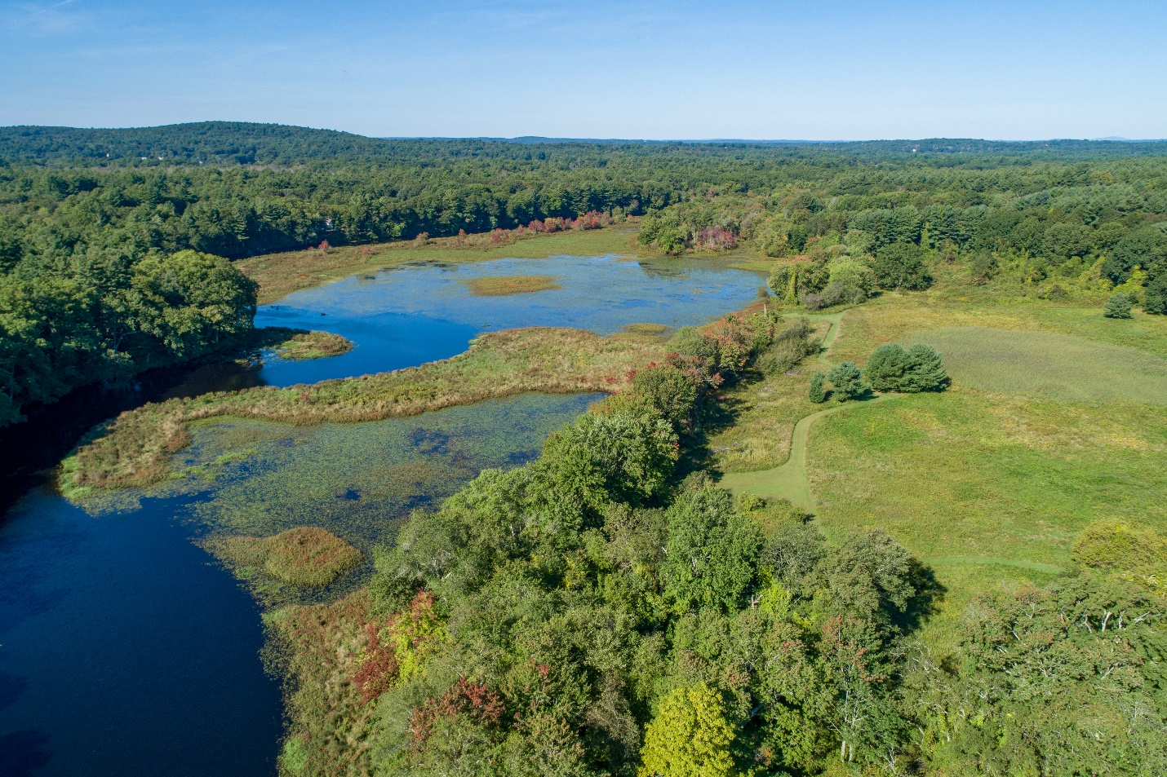

Q. Will Town Meeting Members have access to the property prior to Town Meeting?

A: Yes. The Town has scheduled two tours of the property. The first tour will be at 2:00 p.m. on Sunday, October 16th. The Second tour will be at 10:00 a.m. on Saturday, October 22nd. Attendees should park in the parking lots at the Ridge Hill Reservation. The tour will begin at the driveway to the Ridge Hill Reservation at the intersection of Charles River Street. Carpooling is encouraged. The terrain is uneven and steep in some locations so appropriate footwear is recommended. The property is not suitable for strollers.

Q: What is the total amount of land for sale?

A: The Foster Estate has decided to sell the property known as Castle Farm, totaling approximately 64 acres. Town leadership believes that by partnering with Northland to purchase the land, it has a once-in-a generation opportunity to protect as much of this land as possible.

The Town’s Purchase and Use of the Land

Q: How much of the land would be Town-owned under this proposal?

A: The Town portion of the land would be approximately 34 acres. This includes two parcels along Charles River Street that total approximately 6 acres, and another approximately 28 acres of meadowland along the Charles River. Each of these parcels directly abuts a portion of the Ridge Hill Reservation, which was acquired by the Town in 1981. (There is Town-owned property known as Ridge Hill on both sides of Charles River Street.)

Q: What will the land be used for?

A: The newly acquired land would be offered as an amenity for the community, providing residents greater access to the Charles River, walking trails and recreation. The acquisition would also allow for maintenance of the existing trail network (a portion of which currently travels across the Castle Farm property.)

Q: How will the Town property be accessed?

A: The two 3-acre parcels along Charles River Street can be accessed directly from the street, and via the existing trail network. The approximately 28-acre meadow parcel can be accessed by foot from Charles River Street and the existing trail network. In addition, there will be limited access to the approximately 28-acre parcel for emergency and maintenance purposes via the Northland development parcel. Finally, boat access from the river is an important feature of the acquisition.

Q: Will the land have a conservation restriction on it so that it cannot be developed in the future?

A: The two 3-acre parcels will be acquired for conservation, open space, and passive recreation. The Town will further place a conservation restriction across those parcels, creating a buffer from Charles River Street. The balance of the parcel will be acquired for general municipal purposes but will be used for open space and recreation.

Q: Why is there no conservation restriction contemplated for the larger parcel?

A: The Town is proposing to acquire the larger parcel for “general municipal purposes.” However, once acquired, the larger parcel will be used for open space purposes, will be effectively inaccessible by vehicle, and will be subject to agreement with the seller that it will not be developed as the site of any major municipal buildings. Structuring the agreement this way allows the Town and Town Meeting the greatest flexibility for future planning without precisely limiting all things that can and cannot occur on the property for all time. Holding the property for “general municipal purposes,” subject to the assurances noted above, provides a future value to the Town in the event there is a need to offset an unrelated loss of parkland in other areas of Town.

Q: How much will this cost the Town and how will it be paid for?

A: The Town will pay $2.5 million for approximately 34 acres. The Town is proposing to pay for this through borrowing within the levy limit, colloquially referred to as the “3% debt” formula. Every year, the Town re-examines its future capital needs and adjusts where appropriate. The Town has enough capacity to responsibly borrow these funds. The opportunity to purchase the property is for a limited time and has been deemed by the Select Board as a top priority.

Q: Why didn’t the Town propose to use CPA funds for this acquisition?
A: The project is proposed to be funded through the General Fund for a number of reasons. The acquisition became possible outside the normal cycle for the Community Preservation Committee (CPC). The CPC has worked to create a five-year plan for CPA funds, and an appropriation of this size might disrupt that plan. Moreover, there isn’t sufficient funding in the CPA Open Space reserve to meet the appropriation. Finally, as noted above, the Select Board is recommending the greatest amount of flexibility for the parcel within passive use and open space constraints, and CPA funding comes with restrictions.
Q: Why didn’t the Town purchase and protect the entire property?

A: The purchase price of the entire property is $21 million (including the $2.5 million from the Town). The Select Board has determined that the proposed partnership provides the Town with a significant amount of open space while reserving borrowing capacity for future capital projects, such as the Pollard and Mitchell Schools.

Northland’s Development

Q: How does the partnership benefit Northland?

A: Northland will obtain the remaining land, which is approximately 28 acres, for $18.5 million. The company has proposed building 70 residential units on approximately 14 acres and setting aside the additional 14 acres as an undeveloped buffer/set back area from Whitman Road and around the development area. In total, the envisioned partnership is projected to keep an estimated 48 acres, or 75 percent of the current property, as undeveloped.
Q: Is this the same Northland developer that is building 800 apartments in Newton?

A: No, Northland Residential has no relation to the Northland Investment Corporation that is building the mixed-used development on Needham Street in Newton.

Q: What kind of development is Northland proposing to build?

A: Northland proposes to build a 70-unit high-quality age-directed clustered townhouse neighborhood that would include some affordable housing units. Northland is proposing the project as a Local Initiative Project, also known as a “Friendly 40B.”

Q: What does age-directed mean?

A: Age directed means that the developer will plan and construct units that contain features commonly desired by older adults, such as first floor master bedrooms and bathrooms.

Q: Would these all be resident-owned or apartments?

A: These are contemplated as home ownership.

Q: How does the “Friendly 40B” process work?

A: The proposed project will be permitted as a Local Initiative Project (“LIP”), frequently referred to as a “Friendly 40B.” The first step in the permitting process for a LIP is to obtain a Project Eligibility Letter from the Department of Housing and Community Development (“DHCD”). A developer submits an application for a Project Eligibility Letter along with the Town. This application must be signed by the Town Manager and also includes a letter of support.

The issuance of a Project Eligibility Letter from DHCD is a jurisdictional prerequisite to the filing of a comprehensive permit application for a 40B development (including a LIP). Accordingly, after DHCD issues a Project Eligibility Letter for the project, the developer may then apply for a comprehensive permit from the Zoning Board of Appeals (“ZBA”). If issued, a comprehensive permit covers all permitting requirements under the Town’s by-laws and regulations.

The Zoning Board of Appeals is the permit-granting authority in this case, not the Planning Board.

Q: What will the area look like with the Friendly 40B 70 units built?

A: A concept drawing is attached. Please note that this drawing is conceptual only, and subject to change as Northland prepares plans that are appropriate for permitting.

Q: What will be the impact of the project on traffic?

A: No traffic study has been completed at this time. The Zoning Board of Appeals (ZBA) is likely to require a traffic study as part of the comprehensive permit application process. Town records for traffic counts between Pheasant Landing and Belle Lane in July 2021 indicate 2,950 vehicles per day are heading towards Natick and 2,700 vehicles per day are heading into Needham. This level of traffic would be considered a collector road with medium traffic flow. Peak hour volumes were approximately 280 vehicles in each direction.

Q: What will happen to the house that is on the property?

A: The house that is included in the sale is part of Northland’s purchase and it will be up to the developer to determine its fate.

Q: What happens if Town Meeting rejects the purchase?

A: Town Meeting approval is necessary for this purchase. If the warrant article is rejected, the sellers would have the right to seek a new buyer.

Q: What protections will be in place for the neighbors who abut this property?

A: The partnership itself has some protections built in, including the 14-acre undeveloped area around the proposed residences, which will serve as a buffer between the residents on Whitman Road and the proposed townhome development. In addition, the Town’s purchase of the parcels along Charles River Street protects the scenic view for residents. Neighbors, abutters and interested residents will have a full opportunity to provide input when the ZBA holds a public hearing on the comprehensive permit application.

Q: What is the existing zoning for the property?

A: The property is zoned Rural Residence Conservation (RRC). In the RRC District, single-family detached dwellings may be constructed on lots having a minimum lot size of 43,560 square feet (1 acre) and with 150 feet of frontage. The State Department of Environmental Protection 200-foot Riverfront Area will extend from the Mean Annual High Water or Bank of the River out 200-feet onto the property. There have not been any formal wetland delineations of the property nor a Bank/MAHW line in the field of which the Town’s Conservation staff is aware. Once a field delineation is complete, a 100-foot Buffer Zone to any wetlands located will be protected.

